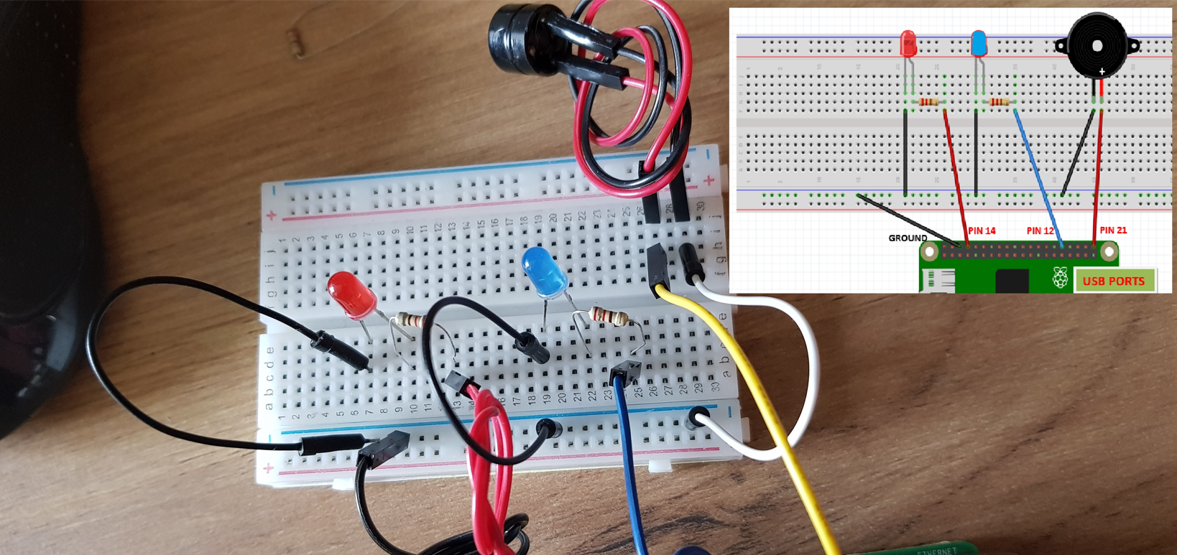

**Putting in all together to make a police car siren**

**Using Thonny Editor to create the program.**

**How to Control the Buzzer**

**>>>**

**Making a continuous beep**

**Making a periodic beep**